**Project Design Phase-II**

**Technology Stack (Architecture & Stack)**

|  |  |
| --- | --- |
| Date | 28 June 2025 |
| Team ID | LTVIP2025TMID58256 |
| Project Name | Visualizing Housing Market Trends: An Analysis Of Sale Prices and Features Using Tableau |
| Maximum Marks | 4 Marks |

**Technical Architecture:**

The Deliverable shall include the architectural diagram as below and the information as per the table1 & table 2

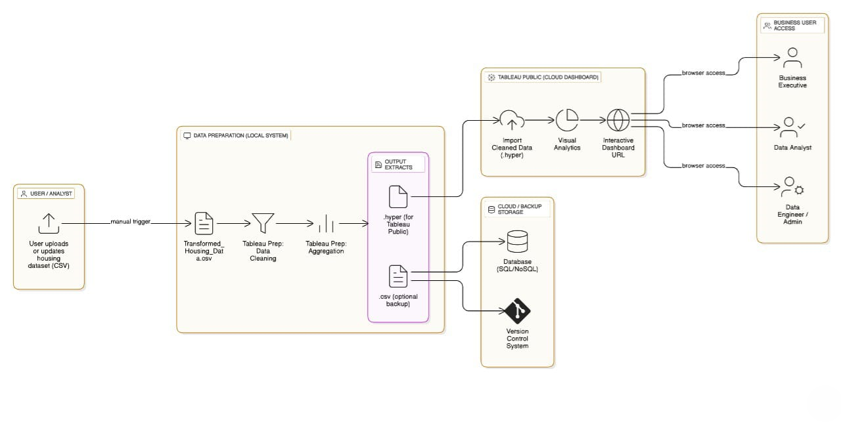

**Table-1 : Components & Technologies:**

|  |  |  |  |
| --- | --- | --- | --- |
| **S.No** | **Component** | **Description** | **Technology** |
| 1 | User Interface | Final dashboard seen by end users | Tableau Public, HTML, Flask |
| 2 | Data Source | Housing dataset source | Google Drive / Local CSV |
| 3 | Data Collection | Gathering dataset for analysis | Manual / Scripted download |
| 4 | Data Preparation | Cleaning & transformation | Tableau Prep |
| 5 | Data Visualization | Building charts & visuals | Tableau Public Desktop |
| 6 | Dashboard & Story | Visual storytelling with filters | Tableau Story |
| 7 | Web Integration | Embedding dashboards into UI | Flask (Python Web Framework) |
| 8 | Hosting Infrastructure | Hosting the Flask app | Localhost / Web server |

**Table-2: Application Characteristics:**

|  |  |  |
| --- | --- | --- |
| **S.No** | **Characteristics** | **Description & Technology** |
| 1 | Open-Source Frameworks | Tableau Public, Flask |
| 2 | Security Implementations | Dataset access via local storage or private Tableau links |
| 3 | Scalable Architecture | Layered and modular architecture flow |
| 4 | Availability | Accessible via Tableau Cloud and Flask Web App |
| 5 | Performance | Optimized Tableau dashboards using filters and cache |

**References:**

[**https://c4model.com/**](https://c4model.com/)

[**https://developer.ibm.com/patterns/online-order-processing-system-during-pandemic/**](https://developer.ibm.com/patterns/online-order-processing-system-during-pandemic/)

[**https://www.ibm.com/cloud/architecture**](https://www.ibm.com/cloud/architecture)

[**https://aws.amazon.com/architecture**](https://aws.amazon.com/architecture)

[**https://medium.com/the-internal-startup/how-to-draw-useful-technical-architecture-diagrams-2d20c9fda90d**](https://medium.com/the-internal-startup/how-to-draw-useful-technical-architecture-diagrams-2d20c9fda90d)